1.To write a command and execute the following statements in kali Linux operating systems

1. To displays the contents of various network-related data structures for active connections.
2. How to test the ability of the source computer to reach a specified destination computer

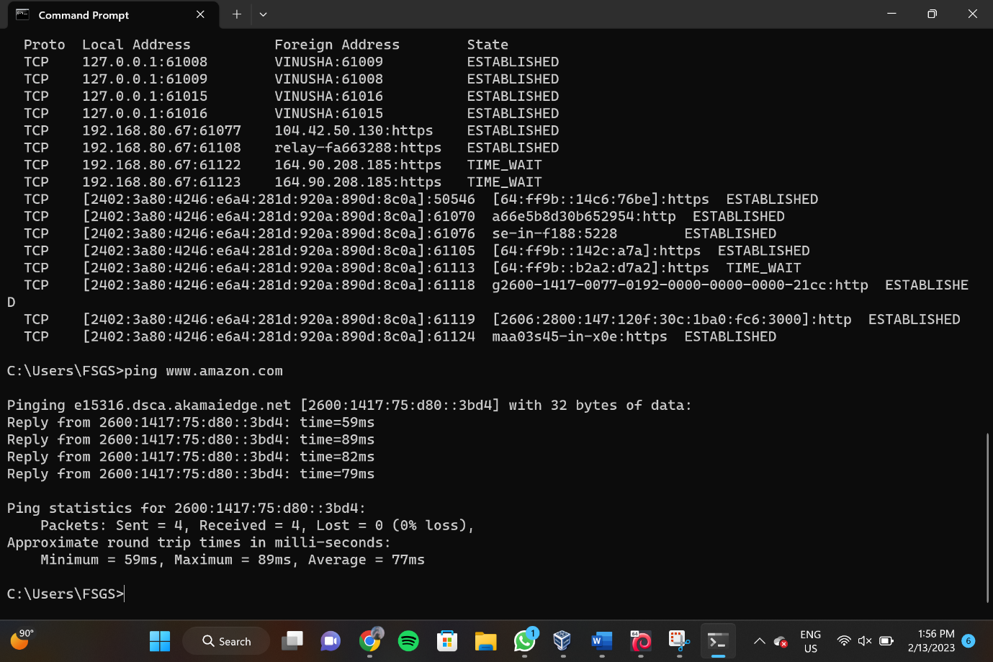

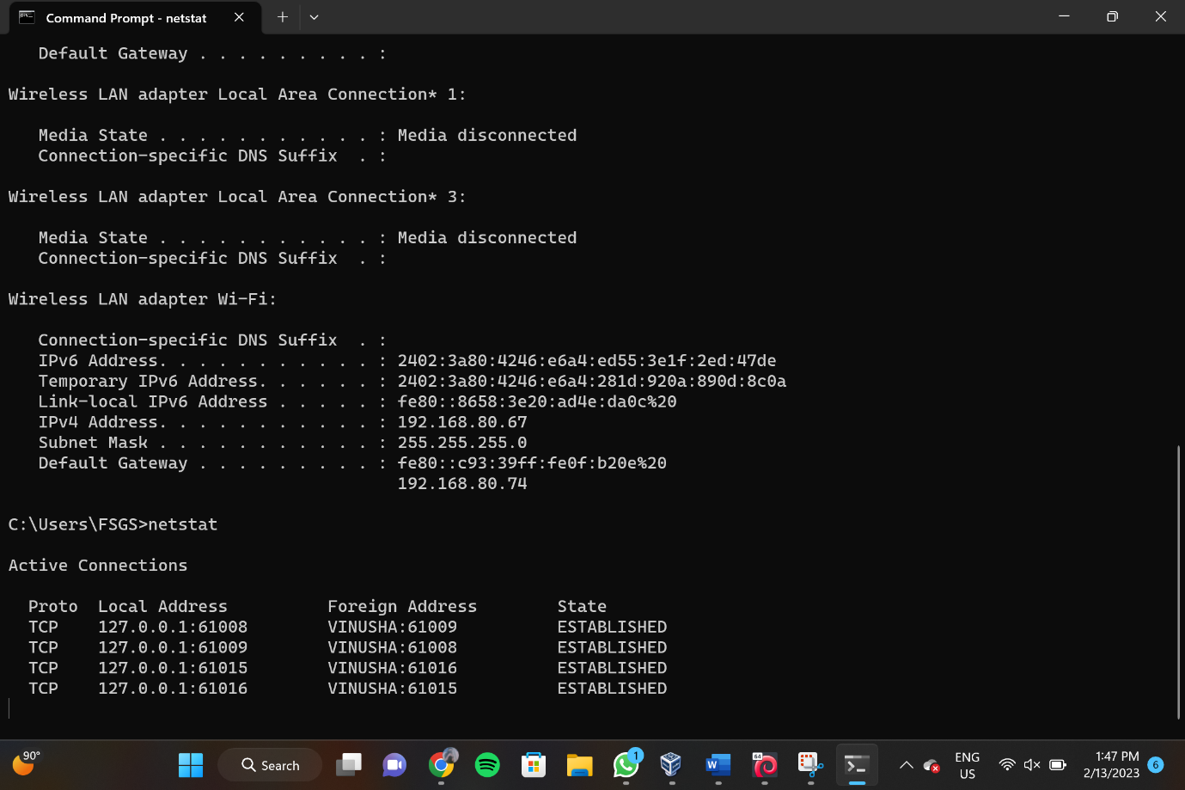

2. By using different flag to find out the timing performance of scanning in kali linux operating systems.

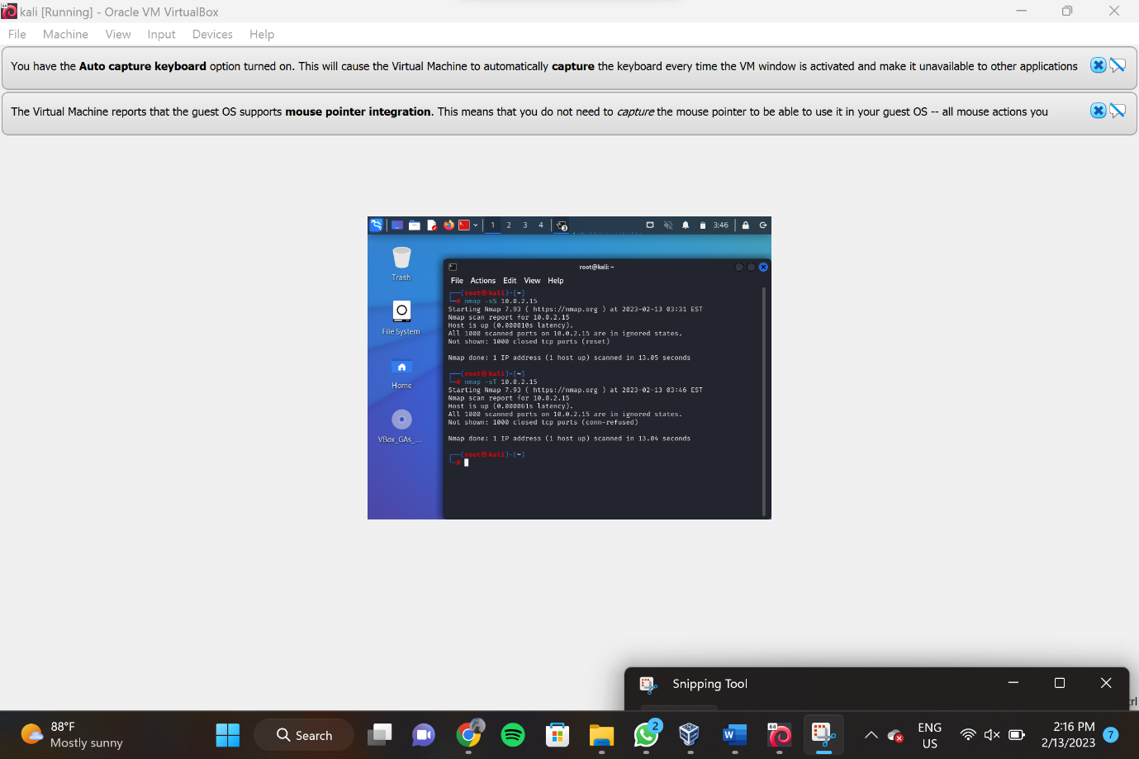

3. You are a systems administrator for a small business, and your customers are reporting connectivity issues. Your goal is to troubleshoot the problem by executing the traceroute and ifconfig commands in Windows operating systems

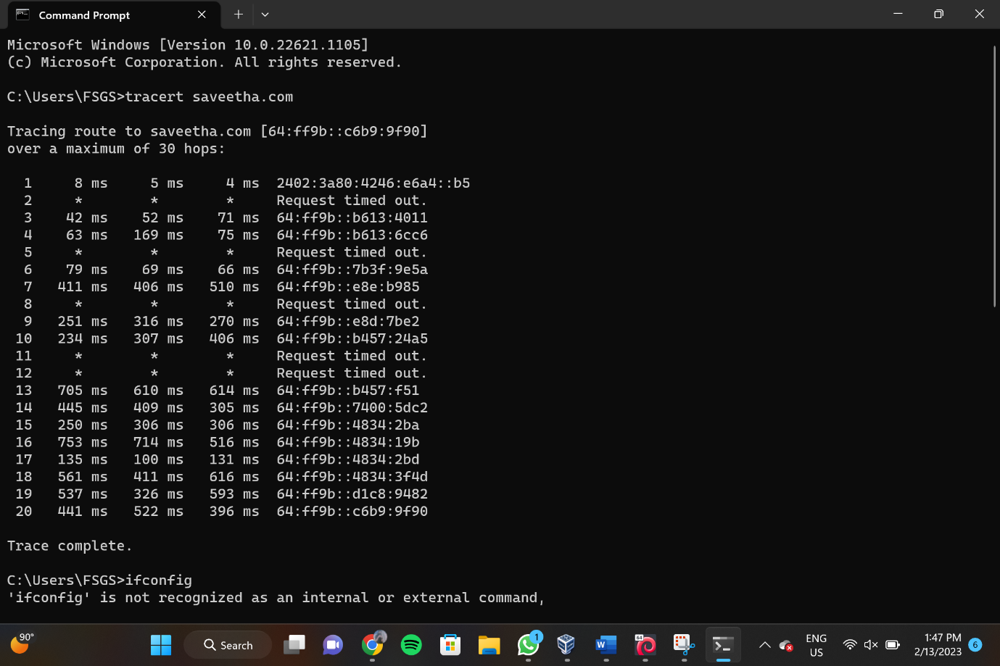

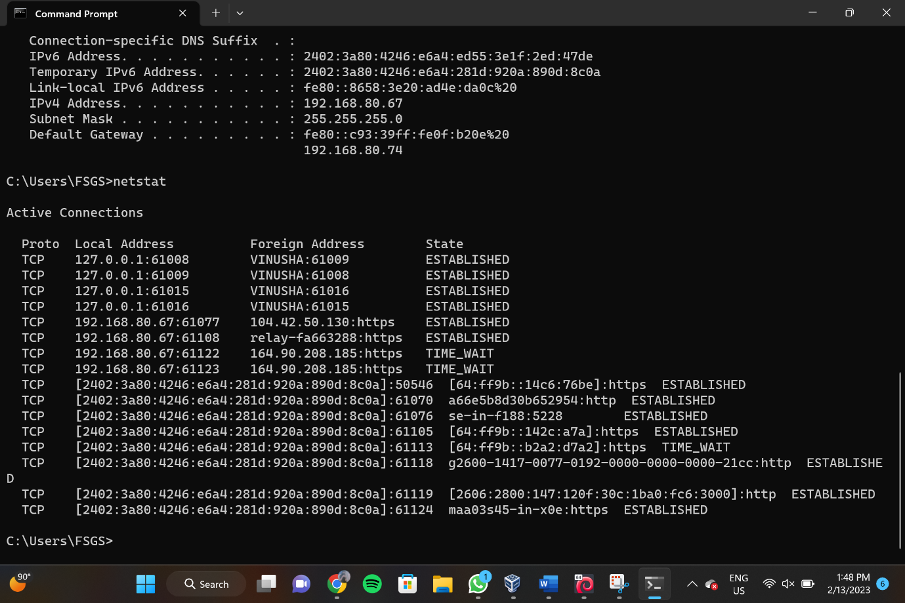

4. To execute the following commands in Kali Linux Operating Systems.

Users Command

Wget command

Date command

